Owen Lindsey
Professor Sparks, James

CST-391 Activity 2
10/6/2024

Angular Directory Structure
Angular Default Folder Structure:
Folder | Purpose
Node_modules/ | Contains all the libraries and dependencies necessary for the project.
src/ | The main folder where the source code of the app lives.
src/app | Stores static assets like images, fonts, and other files that can be used across the app.
src/enviornments | Houses configuration files for different environments, like production or development.
Angular Directory Structure
Angular Default Folder Structure:
File | Purpose
Angular.json | Configuration file for angular CLI that specifies how to build, serve, test, and lint the application.
Package.json | Lists the project dependencies and metadata, including scripts for common commands like build and start.
tsconfig.json | Provides the TypeScript compiler with instructions on how to compile TypeScript code into JavaScript.

Angular Directory Structure
How Angular Generates the Default page:
- main.ts - Initializes the platform that your application runs on, then it uses AppModule to bootsrap the application.

- app.component.*-

- app.component.css: Defines the styles for the root component.
- app.component.html: Contains the HTML template for the root component.
- app.component.ts: Contains the logic for the root component, such as data and behavior.

- app.module.ts: The root module that tells Angular how to assemble the application. It identifies the app’s components, and services.

Angular Folder Content
Details Behind the Default folders:
- node_modules – This directory is auto-generated when you install dependencies for the project using Node Package Manager. You will not need to manually alter the contents of this directory.

- src – is the working directory where most of a developer's time is spent. It contains the logic, views, styles, images, along with whatever else you may need.

- src/app - where the core of the angular application lives. It includes modules, components, services, etc.

- src/assets - A place to store static asset files like images, json, icons, and more.

- src/enviornments - Contains configuration settings for different stages of your application deployment, such as development, staging, and production.

- angular.json - A blueprint for the Angular CLI. It defines various configurations for projects and specifies default settings for builders and schematics.

- package.json - Acts like a manifest for the application. It defines the project dependencies and contains scripts to run tasks like starting the dev server, building the application, and running tests.

- tsconfig.ts - Contains settings for the TypeScript compiler. TypeScript enhances JavaScript with types, and this file includes the rules on how TypeScript should be transpiled into JavaScript.

Angular File Content
Details Behind the Default files:
- main.ts- file is the entry point for an Angular application. It's responsible for bootstrapping the root Angular module (AppModule) to run in the browser.

- app.component.*-
- app.component.css: Styles specific to the appComponent.
- app.component.html: The view template for the appComponent.
- app.component.ts: Contains the logic for the appComponent, including properties and methods.

- App.module.ts -
The app.module.ts file serves as the application's central module. It declares to Angular which components and modules are essential for your app's functionality.

Screenshots
Terminal Showing Angular Version:
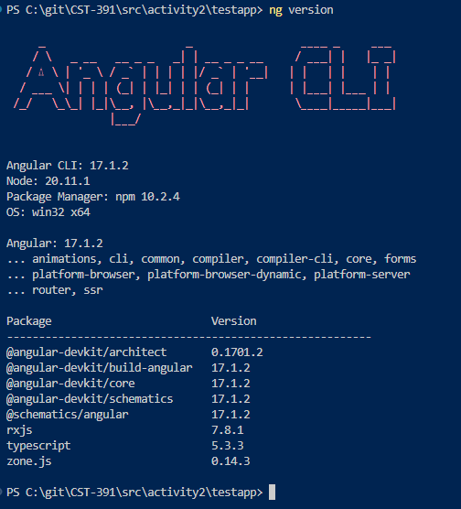

Screenshots
App Initial Page Structure Before Editing:
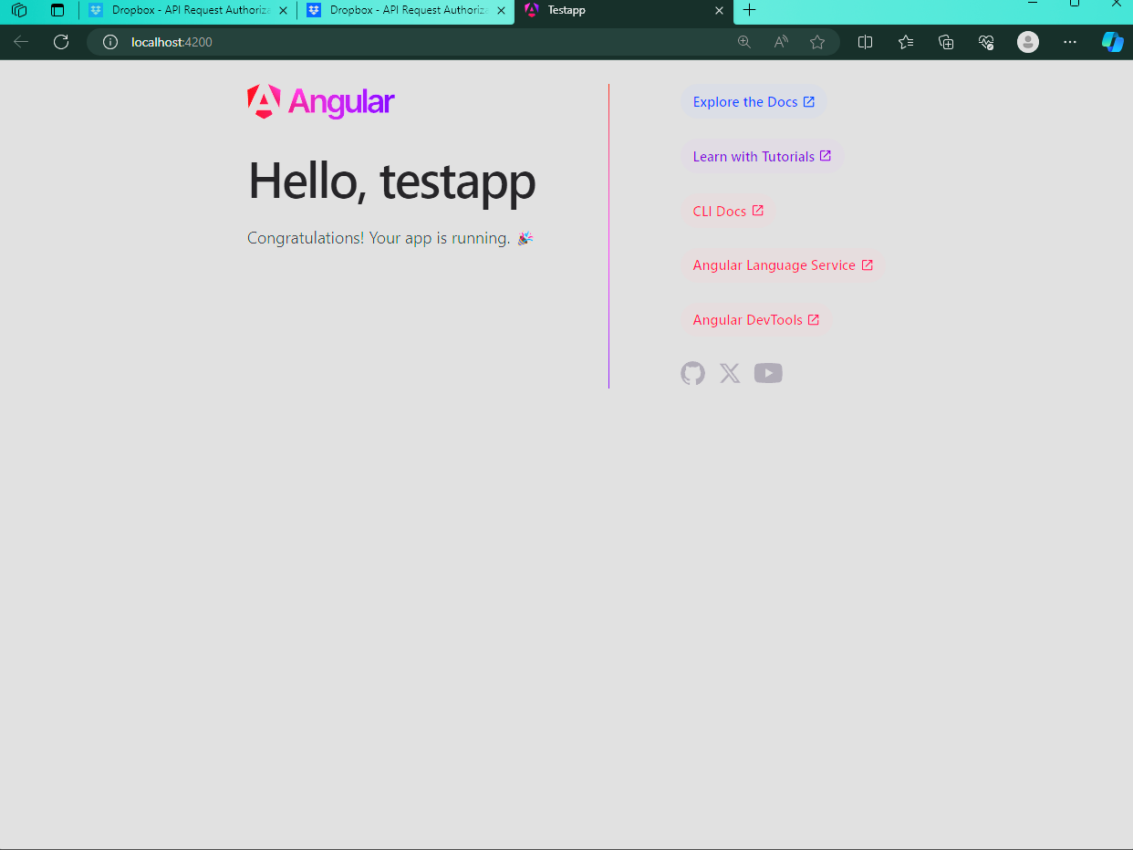

Screenshots
AppComponent edited to show new app name and message below:
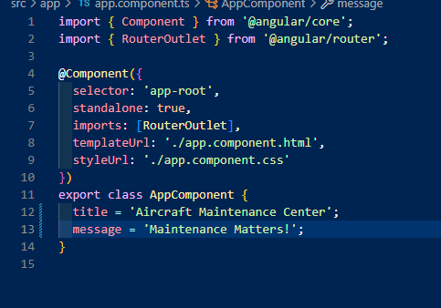

Screenshots
App.component.html edited to display the title and message from component.ts:
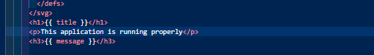

Screenshots
TestApp displaying App Component variables:
